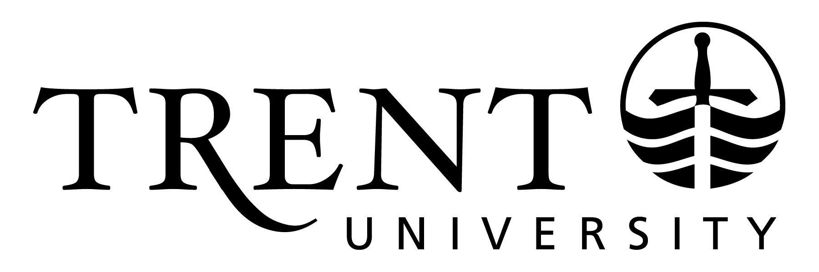
Copyrighted Course Materials - FAQ Resource for Faculty
Frequently asked questions about what to do if your teaching materials are posted online without your consent

This resource was originally created by Toronto Metropolitan University’s Academic Integrity Office (Faculty: Copyright at Toronto Metropolitan). Adapted for Trent University and republished with permission of Toronto Metropolitan University.

- My course materials have been posted on a course sharing site like Course Hero or OneClass – what are my rights?
- How do I get my materials removed from these websites?
- How do I make a Digital Millennium Copyright Act (DMCA) takedown request?
- What do I do if the material is not removed, even after I have sent a takedown request?
- Does Trent’s Academic Integrity Policy apply to the sharing of course content?
- Are students allowed to post their own lecture notes?
- What if I am okay with students posting my material online?

My course materials have been posted on a course sharing site like Course Hero or OneClass – what are my rights?
As an instructor, you own the teaching-related intellectual property that you create at Trent, unless you have assigned rights to the material to another entity by contract. Some examples of the types of materials that are protected by copyright include lecture notes, PowerPoint presentations, lab manuals, syllabuses, and streamed lectures. Instructors are encouraged to remind students, through notices in their syllabuses, that those course materials are protected by copyright laws. You may also choose to include the copyright symbol (©) on your materials along with your name and the date they were created. Make sure that you fully cite any third-party materials in any course material that you use, to make it clear that some material is not your own work and can’t be redistributed. Below is some sample text that you can use on your course outline:
© Copyright [Name], Trent University, for the use of students currently enrolled in [Course code, Academic term/year]. This material may not be reproduced or shared by any means without the permission of the instructor. If you want to share it, please ask.
Course sharing sites are meant to share student-created notes only, but increasingly instructor materials are being shared. For more information about what course sharing sites themselves see as acceptable to post in terms of copyright, please read the Copyright guidelines on the Course Hero site.

How do I get my materials removed from these websites?
If you find teaching materials that you created on a course sharing site, for example Course Hero or OneClass, you can send a request to have the materials taken down. Please note that many course sharing websites such as Course Hero are in the United States, and so can be subject to a Digital Millennium Copyright Act (DMCA) request, which if followed carefully will mean that the company is required by law to remove your materials. A DMCA request only applies to material you created and are the copyright owner of, not to third party materials that are part of your course. You can send a takedown request to a course sharing site like OneClass, but because they are located in Canada and use Canadian servers, they are not required to take the materials down without a court order, although they may choose to do so.
If you would like more information about how to search for your teaching materials posted without your consent, Cornell University has compiled a Copyright Information Centre web page that includes tips for finding your copyrighted materials online. Cornell also includes a sample copyright notice that can be used as a template.
- Course Hero - gives advice on how you can send a request to have the materials taken down. Course Hero includes information on how to submit a request here.
- Chegg - You can report alleged copyright infringement on Chegg sites and submit a takedown request here.
- OneClass - Instructions for how to submit a copyright violation claim to OneClass are available here (scroll down to Copyright Violation Claims section).
- StuDocu - If someone has posted your copyright-protected work to StuDocu without your permission, a takedown request can be submitted here.

How do I make a DMCA takedown request?
To make a DMCA request for your own content to be taken down, you need to put it in the following format and provide the information below. It is a good idea to date your request. You must provide the following information for your request to be enforceable in the United States:
- The name of the copyright claimant (your full name)
- Identification of the copyrighted work claimed to have been infringed (the name of the item)
- Identification of the material that is claimed to be infringing and information reasonably sufficient to permit the service provider to locate the material (a link to the content)
- Information reasonably sufficient to permit the service provider to contact the complaining party, such as an address, telephone number, and, if available, an electronic mail address at which the complaining party may be contacted (your email address or full mailing address)
- A statement that the complaining party has a good faith belief that use of the material in the manner complained of is not authorized by the copyright owner (A statement that claims that you are the copyright holder)
- A statement that the information in the notification is accurate, and under penalty of perjury, that the complaining party is authorized to act on behalf of the owner of the copyright that is allegedly infringed (a statement that you assert you are telling the truth, and that you are in fact the authorized copyright holder)

What do I do if the material is not removed, even after I have sent a takedown request?
You can also send a Cease and Desist letter to follow up. If the cease and desist does not work, you may wish to contact copyright@trentu.ca for advice on other avenues of relief.

Does the Academic Integrity Policy apply to the sharing of course content?
The Trent Undergraduate Academic Integrity Policy includes the following specific example of academic misconduct:
“1.7 – Sharing and Distribution of Course Content - As per the Policy on the Sharing and Distribution of Course Content, sharing and distribution of any course content other than among individual students registered in the course is not permitted without written permission of the instructor. Sharing and distribution means providing access to course content in any form to non-course participants or generally making such content accessible to others, which may involve uploading/downloading or transferring course content to, or from, another device, system or network, including but not limited to any publicly accessible website, chat group, social media, or other internet platform.”

In the Trent Policy on the Sharing and Distribution of Course Content, “course content” means all materials developed for the delivery of a particular course. This includes, but is not limited to, lectures, visual material, lab manuals, class discussions, assignments, and exams.
This means that the Academic Integrity Policy may apply. If your students share your materials, without your authorization, you may wish to complete the steps for an investigation of academic dishonesty and submit a report to the chair.

Are students allowed to post their own lecture notes?
Student created, non-verbatim (in their own words) notes of class lectures are acceptable for students to share, as these are created by students in their own words, and so are copyrighted to them. Moreover, if students post short excerpts of your work to a non-commercial site, for a fair dealing purpose (such as criticism, review, education, news reporting) then their use may qualify as fair dealing.

What if I am okay with students posting my material online?
You may not have an issue with students posting your course material online. If that is the case, consider informing students in your course outline that you are making the course materials available by a Creative Commons Licence, enabling students to further copy and distribute it (see the Creative Commons site to choose the most applicable licence type).

